Locust Test Report

During: 11/17/2022, 5:24:47 PM - 11/17/2022, 5:34:15 PM

Target Host: http://127.0.0.1:5000 Script: locustfile.py

**Request Statistics**

|  |  |  |  |  |  |  |  |  |  |  |
| --- | --- | --- | --- | --- | --- | --- | --- | --- | --- | --- |
| **Method** | **Name** | **# Requests** | **# Fails** | **Average (ms)** | **Min (ms)** | **Max (ms)** | **Average size (bytes)** | | **RPS** | **Failures/s** |
| GET | / | 1890 | 0 | 5 | 4 | 41 | 6381 | | 3.3 | 0.0 |
| GET | /prediction | 1828 | 0 | 5 | 4 | 34 | 4484 | | 3.2 | 0.0 |
|  | **Aggregated** | **3718** | **0** | **5** | **4** | **41** | **5448** | | **6.5** | **0.0** |
| **esponse Time Statistics** | | | | | | | | | | |
| **Method** | **Name** | **50%ile (ms)** | **60%ile (ms)** | **70%ile (ms)** | **80%ile (ms)** | **90%ile (ms)** | **95%ile (ms)** | **99%ile (ms)** | | **100%ile (ms)** |
| GET | / | 5 | 5 | 6 | 6 | 7 | 9 | 19 | | 41 |
| GET | /prediction | 5 | 5 | 6 | 6 | 7 | 9 | 19 | | 34 |
|  | **Aggregated** | **5** | **5** | **6** | **6** | **7** | **9** | **19** | | **41** |

**R**

**Charts**

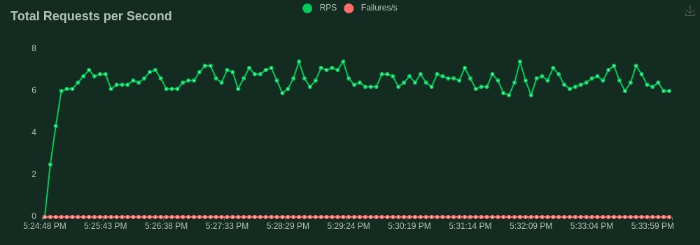

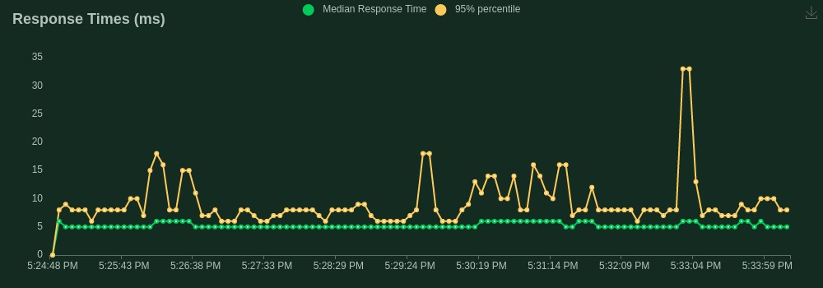

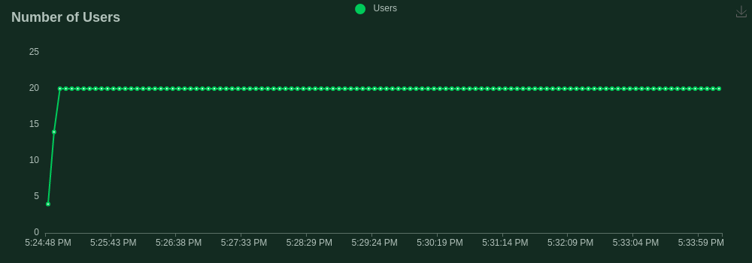

**Final ratio**

# Ratio per User class

100.0% AppUser

50.0% home

50.0% prediction

# Total ratio

100.0% AppUser

50.0% home

50.0% prediction